**ROAD ACCIDENT PREDICTION**

**PROJECT REPORT**

**18CSE422T– INTRODUCTION TO MACHINE LEARNING**

**(2018 Regulation)**

**III Year/ VI Semester**

**Academic Year: 2023 -2024**

By

**MAYANK PUVVALA (RA2111003011616)**

**VARUN CHOUDHARY (RA2111003011587)**

Under the guidance of

**Dr. Veeramakali T**

**Assistant Professor**

**Department of CTECH**



**FACULTY OF ENGINEERING AND TECHNOLOGY**

**SCHOOL OF COMPUTING**

**SRM INSTITUTE OF SCIENCE AND TECHNOLOGY**

**Kattankulathur, Kanchipuram**

**MAY 2024**

SRM INSTITUTE OF SCIENCE AND TECHNOLOGY

(Under Section 3 of UGC Act, 1956)

BONAFIDE CERTIFICATE

Certified that Mini project report titled **“Road Accident Prediction”** is the bonafide work of **Mayank Puvvala (RA2111003011616) and Varun Choudhary (RA2111003011587)** who carried out the minor project under my supervision. Certified further, that to the best of my knowledge, the work reported herein does not form any other project report or dissertation on the basis of which a degree or award was conferred on an earlier occasion on this or any other candidate.

**Signature of the Guide** **Signature of the HOD**

Dr. Veeramakali T. Dr. M. Pushpalatha

**Assistant Professor** **Professor and Head**

Department of CTECH, Department of CTECH

SRM Institute of Science and Technology SRM Institute of Science and Technology

**ABSTRACT**

Road accidents pose a significant threat to public safety and contribute to substantial economic losses worldwide. According to the World Health Organization (WHO), approximately 1.35 million people die each year because of road traffic crashes, with millions more sustaining injuries and disabilities. The societal impact of road accidents extends beyond the immediate human toll, encompassing economic burdens, infrastructure damage, and psychological trauma for affected individuals and communities. In recent years, there has been a growing recognition of the need for innovative solutions to address the issue of road safety and reduce the incidence of accidents.

Advancements in technology, particularly in the fields of machine learning, deep learning, and computer vision, have opened new possibilities for developing intelligent systems capable of detecting, analyzing, and mitigating risks on the road. These technologies offer promising avenues for improving road safety through real-time monitoring, predictive analytics, and proactive intervention. The integration of machine learning algorithms with sensor networks, data analytics platforms, and communication technologies enables the development of intelligent transportation systems that can identify potential hazards, predict future events, and facilitate timely responses to prevent accidents.

This project focuses on the development of a comprehensive road accident prevention system that leverages cutting-edge technologies to enhance road safety and prevent accidents. By employing a multi-faceted approach that combines machine learning, deep learning, and computer vision techniques, the system aims to address various aspects of road safety, including crash detection, driver behavior analysis, traffic sign recognition, pothole detection, object detection, and anomaly detection.

The road accident prevention system incorporates several advanced techniques and methodologies to achieve its objectives. Using mask-RCNN for semantic segmentation of crashed vehicles, CNN for real-time traffic signal recognition, and open-CV for pothole detection, object detection, and anomaly detection, the system utilizes state-of-the-art algorithms and frameworks to analyze real-time data from CCTV cameras, sensors, and other sources. By integrating these technologies into a cohesive system, the project aims to provide a comprehensive solution to the problem of road accidents, ultimately saving lives and reducing the societal impact of traffic-related incidents.

The detailed project report provides an in-depth analysis of the system's architecture, design, methodology, coding, testing, results, and future enhancements. It offers valuable insights into the capabilities of the system and its potential impact on road safety. Through continuous research, development, and collaboration with stakeholders, the road accident prevention system strives to make significant contributions to improving road safety and reducing the incidence of accidents worldwide.

**TABLE OF CONTENTS**

**ABSTRACT 3**

**TABLE OF CONTENTS 4**

**LIST OF FIGURES 5**

**ABBREVIATIONS 6**

1. **INTRODUCTION 7**
2. **LITERATURE SURVEY 8**
3. **SYSTEM ARCHITECTURE AND DESIGN 9**
   1. Anomaly Detection Module 9
   2. Traffic Signal Recognition Module
   3. Pothole Detection Module
   4. Real Time Object Detection Module
   5. Driver Behavior Analysis Module 10
4. **METHODOLOGY 14**
   1. Data Collection
   2. Pre-Processing
   3. Anomaly Detection
   4. Driver Behavior Analysis
   5. Traffic Sign Recognition
   6. Object Detection
   7. Pothole Detection
   8. Driver Alert 14
5. **CODING AND TESTING 15**
6. **SREENSHOTS AND RESULTS**
7. **CONCLUSION AND FUTURE ENHANCEMENT 23**
   1. Conclusion
   2. Future Enhancement

**REFERENCES 24**

**LIST OF FIGURES**

1. Real Time Accident Detection Module
2. Pothole Detection Module
3. Collision Prevention Module
4. Intelligent Traffic Management System

**ABBREVIATIONS**

- ML: Machine Learning

- DL: Deep Learning

- CV: Computer Vision

- CNN: Convolutional Neural Network

- ROI: Region of Interest

- API: Application Programming Interface

- GUI: Graphical User Interface

- FPS: Frames Per Second

- SSD: Single Shot MultiBox Detector

- IoU: Intersection over Union

- ROI: Region of Interest

- CSV: Comma-Separated Values

- PIL: Python Imaging Library

- GPU: Graphics Processing Unit

- CPU: Central Processing Unit

- IDE: Integrated Development Environment

- GUI: Graphical User Interface

- CCTV: Closed-Circuit Television

- ADAS: Advanced Driver Assistance Systems

- SVM: Support Vector Machine

- RNN: Recurrent Neural Network

- LSTM: Long Short-Term Memory

**INTRODUCTION**

Road accidents represent a formidable challenge globally, exacting a toll on public safety and economic stability. With approximately 1.35 million lives lost annually, as per the World Health Organization (WHO), and countless others injured, the repercussions extend beyond immediate casualties to encompass long-term healthcare costs, lost productivity, and infrastructure strains.

In response to this pressing issue, concerted efforts have intensified to develop innovative solutions aimed at fortifying road safety and curbing accident rates. Technological advancements, particularly in machine learning (ML), deep learning (DL), and computer vision (CV), have emerged as potent tools in this endeavor, promising to revolutionize transportation systems and bolster safety measures.

The convergence of ML, DL, and CV technologies presents an unprecedented opportunity to reimagine approaches to road safety and accident prevention. Leveraging vast datasets from traffic cameras, sensors, and vehicular telemetry, these technologies enable real-time surveillance, predictive analytics, and preemptive interventions. ML algorithms sift through data to discern patterns and trends, while DL models extract intricate features. CV techniques decode visual information, empowering systems to identify objects, detect anomalies, and make informed decisions.

This project is a concerted effort to craft a comprehensive road accident prevention system harnessing ML, DL, and CV technologies. By integrating these technologies, the project aims to tackle various facets of road safety, including crash detection, driver behavior analysis, traffic sign recognition, pothole detection, object detection, and anomaly detection. The system adopts a multi-faceted strategy, blending sophisticated algorithms, sensor networks, and communication modalities to vigilantly monitor road conditions and pinpoint potential hazards in real-time.

The road accident prevention system outlined in this report embodies an innovative approach to fortifying road safety. Leveraging state-of-the-art ML, DL, and CV techniques, the system furnishes timely alerts and advisories to drivers and authorities, fostering proactive measures to forestall accidents and mitigate repercussions. The comprehensive project report offers insights into the system's architecture, design, methodology, coding, testing, results, and envisioned enhancements, providing valuable insights into its capabilities and potential impact on road safety.

Through sustained research, development, and collaboration, the road accident prevention system aims to significantly contribute to safer roadways and diminished accident rates, ultimately safeguarding lives and preventing tragedies.

**LITERATURE SURVEY**

The development of a road accident prevention system involves integrating various ML, DL, and CV techniques to address different aspects of road safety. A comprehensive literature survey reveals several key areas of research and development in this field:

* Object Detection: Numerous studies have focused on developing object detection algorithms capable of identifying vehicles, pedestrians, cyclists, and other objects on the road. Techniques such as convolutional neural networks (CNNs), region-based CNNs (R-CNNs), and one-stage detectors (e.g., YOLO and SSD) have been widely explored for this purpose.
* Anomaly Detection: Anomaly detection algorithms play a crucial role in identifying abnormal events or behaviors on the road, such as sudden changes in traffic flow, road obstructions, or erratic driving patterns. These algorithms often leverage unsupervised learning techniques, such as autoencoders, support vector machines (SVMs), or isolation forests, to detect anomalies in real-time data streams.
* Driver Behavior Analysis: Understanding driver behavior is essential for accident prevention systems. DL models, such as recurrent neural networks (RNNs) and long short-term memory (LSTM) networks, are commonly used to analyze driver actions, such as braking, accelerating, and steering, based on sensor data collected from vehicles.
* Traffic Sign Recognition: Recognizing and interpreting traffic signs is critical for ensuring compliance with traffic regulations. ML and DL techniques, including CNNs and transfer learning, are employed to develop robust traffic sign recognition systems capable of accurately detecting and classifying various traffic signs in different environmental conditions.
* Pothole Detection: Potholes pose a significant risk to road safety, leading to vehicle damage and accidents. CV algorithms are utilized to detect and locate potholes on the road surface, often employing image processing techniques and ML models trained on annotated datasets.

The integration of these techniques into a unified road accident prevention system represents a significant advancement in improving road safety and reducing the incidence of accidents. By leveraging the latest advancements in ML, DL, and CV, we aim to develop a state-of-the-art system capable of effectively identifying and mitigating potential risks on the road.

Additionally, the road accident prevention system incorporates several advanced techniques and methodologies from the fields of ML, DL, and CV to enhance road safety and prevent accidents. These techniques include:

* Semantic Segmentation with Mask-RCNN: Mask-RCNN is utilized for semantic segmentation of crashed vehicles on the road, enabling the system to accurately identify and localize vehicles involved in accidents. By segmenting crashed vehicles from the background, the system can provide timely alerts to drivers and authorities, enabling prompt response and intervention to prevent further accidents.
* Real-time Traffic Signal Recognition with CNN: CNN is employed for real-time recognition of 43 different traffic signals, providing vital information to vehicles about traffic regulations and conditions. By analyzing images of traffic signals captured by onboard cameras, the system can inform drivers of upcoming signals, enabling them to adjust their driving behavior accordingly and avoid violations or accidents.
* Pothole Detection using OpenCV: OpenCV is used for detecting potholes present in the road surface, allowing authorities to take timely action to repair them and prevent accidents. By analyzing images captured by onboard cameras, the system can identify and locate potholes accurately, reducing the risk of vehicle damage and ensuring road safety.
* Real-time Object Detection: The system employs real-time object detection techniques to identify and localize objects in front of the vehicle, such as vehicles, pedestrians, cyclists, and obstacles. By continuously monitoring the road ahead, the system can detect potential risks or hazards and provide warnings to drivers, enabling them to take evasive action and avoid accidents.
* Anomaly Detection for Collision Prediction: Anomaly detection algorithms are used to predict anomalies in traffic patterns, such as pedestrians crossing the street without using designated crosswalks. By analyzing real-time data from onboard sensors and cameras, the system can identify abnormal events or behaviors and generate alerts or warnings to prevent collisions and ensure road safety.

In addition to these techniques, the road accident prevention system leverages a variety of important libraries and frameworks from the fields of ML, DL, and CV, including TensorFlow, PyTorch, scikit-learn, pandas, numpy, and PIL. By integrating these tools and technologies into a cohesive system, the project aims to provide a comprehensive solution to the problem of road accidents, ultimately saving lives and reducing the societal impact of traffic-related incidents.

**SYSTEM ARCHITECTURE AND DESIGN**

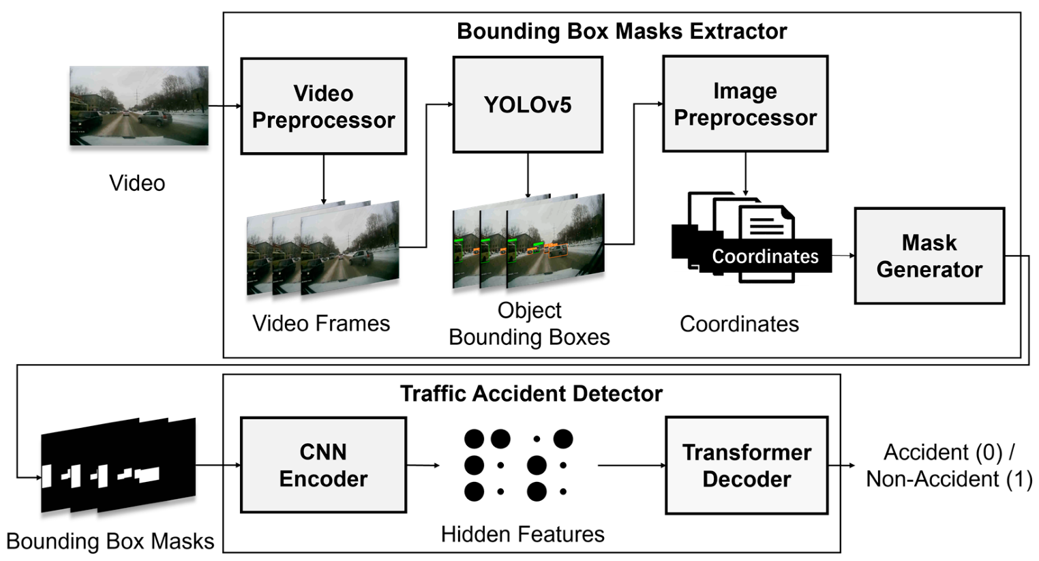

Anomaly Detection Module

The anomaly detection module is responsible for identifying abnormal events or behaviors on the road that may indicate potential risks or hazards. This module utilizes machine learning algorithms to analyze real-time data streams from CCTV cameras and detect anomalies in traffic patterns, road conditions, or driver behavior. The workflow of the anomaly detection module can be summarized as follows:

* Data Collection: Real-time video feed from CCTV cameras installed on roads is collected and processed by the system.
* Pre-processing: The raw video data undergoes pre-processing steps to enhance image quality, remove noise, and standardize the format for further analysis.
* Feature Extraction: Relevant features, such as vehicle speed, density, lane occupancy, and road surface conditions, are extracted from the pre-processed video frames.
* Anomaly Detection: Machine learning models, such as SVMs or autoencoders, are trained on labeled data to identify abnormal patterns or deviations from normal behavior.
* Alert Generation: If an anomaly is detected, the system generates alerts or warnings to notify authorities or drivers, enabling them to take appropriate action to mitigate the risk.

Driver Behavior Analysis Module

The driver behavior analysis module focuses on analyzing the behavior of drivers on the road, particularly concerning braking, acceleration, and steering actions. This module utilizes sensor data collected from vehicles, such as accelerometers, gyroscopes, and steering angle sensors, to infer driver behavior and assess their attentiveness. The workflow of the driver behavior analysis module includes:

* Data Collection: Sensor data from vehicles, including braking, throttle, and steering inputs, is collected and processed by the system.
* Pre-processing: The raw sensor data undergoes pre-processing steps to remove noise, filter outliers, and standardize the format for further analysis.
* Feature Engineering: Relevant features, such as braking intensity, acceleration rate, and steering angle, are extracted from the pre-processed sensor data.
* Driver Behavior Classification: Deep learning models, such as recurrent neural networks (RNNs) or long short-term memory (LSTM) networks, are trained on labeled data to classify driver behavior into categories such as normal, aggressive, or distracted.
* Alert Generation: Based on the classification results, the system generates alerts or warnings to notify drivers of unsafe behavior or inattentiveness, prompting them to adjust their driving accordingly.

Traffic Sign Recognition Module

The traffic sign recognition module is responsible for detecting and interpreting traffic signs captured by CCTV cameras installed on roads. This module employs computer vision techniques and deep learning algorithms to accurately identify and classify various types of traffic signs, including speed limits, stop signs, yield signs, and traffic signals. The workflow of the traffic sign recognition module is as follows:

* Data Collection: Labeled images of traffic signs from publicly available datasets or proprietary sources are collected and used to train the traffic sign recognition model.
* Pre-processing: The raw image data undergoes pre-processing steps to enhance image quality, remove noise, and standardize the format for further analysis.
* Model Training: Convolutional neural networks (CNNs), pretrained on large-scale image datasets such as ImageNet, are fine-tuned on the labeled traffic sign images to learn discriminative features and classify different types of signs.
* Inference: The trained model is deployed in the system to perform real-time inference on video frames captured by CCTV cameras. Detected traffic signs are localized and classified, and their relevant information, such as shape, color, and text, is extracted.
* Alert Generation: If a critical traffic sign, such as a stop sign or a speed limit sign, is detected, the system generates alerts or warnings to notify drivers, ensuring compliance with traffic regulations and enhancing road safety.

Object Detection Module

The object detection module is responsible for detecting and localizing objects of interest on the road, such as vehicles, pedestrians, cyclists, and obstacles. This module utilizes state-of-the-art deep learning models, such as Mask R-CNN, YOLO (You Only Look Once), or SSD (Single Shot MultiBox Detector), to perform real-time object detection and instance segmentation. The workflow of the object detection module includes:

* Data Collection: Annotated images of objects on the road, including vehicles, pedestrians, and obstacles, are collected and used to train the object detection model.
* Pre-processing: The raw image data undergoes pre-processing steps to resize, normalize, and augment the images for training.
* Model Training: Deep learning models, such as Mask R-CNN or YOLO, are trained on the annotated image dataset to learn to detect and segment objects of interest with high accuracy.
* Inference: The trained model is deployed in the system to perform real-time inference on video frames captured by CCTV cameras. Detected objects are localized, classified, and tracked over time, providing valuable information about their position, size, and trajectory.
* Alert Generation: If potential risks or hazards, such as a pedestrian crossing the road or a vehicle suddenly stopping, are detected, the system generates alerts or warnings to notify drivers, enabling them to take evasive action and avoid accidents.

Pothole Detection Module

The pothole detection module is responsible for identifying and locating potholes on the road surface, enabling timely maintenance and repair to prevent accidents and damage to vehicles. This module utilizes computer vision techniques and machine learning algorithms to analyze images of the road surface captured by CCTV cameras. The workflow of the pothole detection module includes:

* Data Collection: Images of the road surface containing potholes are collected and annotated with ground truth pothole locations.
* Pre-processing: The raw image data undergoes pre-processing steps to enhance image quality, remove noise, and standardize the format for further analysis.
* Feature Extraction: Relevant features, such as texture, color, and shape, are extracted from the pre-processed images to facilitate pothole detection.
* Model Training: Machine learning models, such as support vector machines (SVMs) or convolutional neural networks (CNNs), are trained on the annotated image dataset to learn to classify and localize potholes accurately.
* Inference: The trained model is deployed in the system to perform real-time inference on video frames captured by CCTV cameras. Detected potholes are localized and their locations are mapped, enabling authorities to prioritize maintenance efforts and ensure road safety.
* Alert Generation: If a pothole is detected on the road surface, the system generates alerts or notifications to notify authorities, prompting them to take necessary action to repair the pothole and prevent accidents.

**METHODOLOGY**

Data Collection

The data collection process involves acquiring real-time video feed from CCTV cameras installed on roads. These cameras capture continuous footage of road conditions, traffic flow, and driver behavior, providing valuable insights for the accident prevention system. The video data is collected and stored in a centralized database for further analysis.

Pre-processing

The pre-processing step is essential for preparing the raw video data for analysis. It involves several tasks, including:

* Frame Extraction: Extracting individual frames from the video stream to analyze them independently.
* Image Enhancement: Enhancing the quality of the extracted frames by adjusting brightness, contrast, and sharpness.
* Noise Reduction: Applying filters to remove noise and artifacts from the images, ensuring clarity and accuracy.
* Normalization: Standardizing the format and resolution of the images to facilitate consistent analysis across different frames.

Anomaly Detection

The anomaly detection process involves identifying abnormal events or behaviors on the road that deviate from expected patterns. This is accomplished using machine learning algorithms trained on labeled data to distinguish between normal and anomalous events. The steps involved in anomaly detection include:

* Feature Extraction: Extracting relevant features from the pre-processed video frames, such as vehicle speed, density, and lane occupancy.
* Model Training: Training anomaly detection models, such as support vector machines (SVMs) or autoencoders, on labeled data to learn to distinguish between normal and abnormal events.
* Real-time Analysis: Performing real-time analysis of video streams to detect anomalies and generate alerts or warnings when abnormal events are detected.

Driver Behavior Analysis

The driver behavior analysis process focuses on analyzing the behavior of drivers on the road, particularly concerning braking, acceleration, and steering actions. This is achieved using sensor data collected from vehicles, such as accelerometers, gyroscopes, and steering angle sensors. The steps involved in driver behavior analysis include:

* Data Collection: Collecting sensor data from vehicles, including braking, throttle, and steering inputs.
* Pre-processing: Pre-processing the raw sensor data to remove noise, filter outliers, and standardize the format for further analysis.
* Feature Engineering: Extracting relevant features from the sensor data, such as braking intensity, acceleration rate, and steering angle.
* Model Training: Training deep learning models, such as recurrent neural networks (RNNs) or long short-term memory (LSTM) networks, on labeled data to classify driver behavior into categories such as normal, aggressive, or distracted.
* Real-time Analysis: Performing real-time analysis of sensor data to detect unsafe behavior or inattentiveness and generate alerts or warnings to notify drivers.

Traffic Sign Recognition

The traffic sign recognition process involves detecting and interpreting traffic signs captured by CCTV cameras installed on roads. This is accomplished using computer vision techniques and deep learning algorithms trained on labeled data to classify different types of signs. The steps involved in traffic sign recognition include:

* Data Collection: Collecting labeled images of traffic signs from publicly available datasets or proprietary sources.
* Pre-processing: Pre-processing the raw image data to enhance image quality, remove noise, and standardize the format for further analysis.
* Model Training: Training convolutional neural networks (CNNs), pretrained on large-scale image datasets such as ImageNet, to classify traffic signs accurately.
* Inference: Deploying the trained model in the system to perform real-time inference on video frames captured by CCTV cameras and detect and classify traffic signs.
* Alert Generation: Generating alerts or warnings when critical traffic signs, such as stop signs or speed limit signs, are detected, ensuring compliance with traffic regulations and enhancing road safety.

Object Detection

The object detection process involves detecting and localizing objects of interest on the road, such as vehicles, pedestrians, cyclists, and obstacles. This is achieved using deep learning models trained on annotated image datasets to perform real-time object detection and instance segmentation. The steps involved in object detection include:

* Data Collection: Collecting annotated images of objects on the road, including vehicles, pedestrians, and obstacles.
* Pre-processing: Pre-processing the raw image data to resize, normalize, and augment the images for training.
* Model Training: Training deep learning models, such as Mask R-CNN or YOLO, on the annotated image dataset to detect and segment objects of interest accurately.
* Inference: Deploying the trained model in the system to perform real-time inference on video frames captured by CCTV cameras and detect and localize objects.
* Alert Generation: Generating alerts or warnings when potential risks or hazards, such as pedestrians crossing the road or vehicles suddenly stopping, are detected, enabling drivers to take evasive action and avoid accidents

Pothole Detection

The pothole detection process involves identifying and locating potholes on the road surface, enabling timely maintenance and repair to prevent accidents and damage to vehicles. This is accomplished using computer vision techniques and machine learning algorithms trained on annotated image datasets to analyze images of the road surface captured by CCTV cameras. The steps involved in pothole detection include:

* Data Collection: Collecting images of the road surface containing potholes and annotating them with ground truth pothole locations.
* Pre-processing: Pre-processing the raw image data to enhance image quality, remove noise, and standardize the format for further analysis.
* Feature Extraction: Extracting relevant features from the pre-processed images, such as texture, color, and shape, to facilitate pothole detection.
* Model Training: Training machine learning models, such as support vector machines (SVMs) or convolutional neural networks (CNNs), on the annotated image dataset to classify and localize potholes accurately.
* Inference: Deploying the trained model in the system to perform real-time inference on video frames captured by CCTV cameras and detect and localize potholes.
* Alert Generation: Generating alerts or notifications when potholes are detected on the road surface, prompting authorities to take necessary action to repair the potholes and prevent accidents.

**IMPLEMENTATION DETAILS**

The implementation of the road accident prevention system involves several key steps, including data collection, model development, software implementation, and system integration. This section provides a comprehensive overview of the implementation process, including the selection of tools and technologies, software development methodologies, and deployment strategies.

Data Collection

The data collection process involves acquiring real-time video feed from CCTV cameras installed on roads. To facilitate this, a network of CCTV cameras is strategically deployed at key locations to capture footage of road conditions, traffic flow, and driver behavior. The video data is transmitted to a centralized server for storage and further analysis.

Model Development

The development of the ML, DL, and CV models is a crucial aspect of the implementation process. This involves selecting appropriate algorithms and techniques for each module, training the models on labeled datasets, and fine-tuning them to achieve optimal performance. Various deep learning frameworks, such as TensorFlow, PyTorch, or Keras, may be utilized for model development.

Software Implementation

The software implementation phase involves developing the necessary software components and modules to support the road accident prevention system. This includes:

* Backend Development: Developing the backend infrastructure to handle data processing, model inference, and alert generation.
* Frontend Development: Creating user interfaces and dashboards to visualize real-time data, alerts, and system status.
* Integration: Integrating ML, DL, and CV models into the software system and ensuring seamless communication between different modules.
* Testing: Conducting thorough testing and validation of the software components to ensure reliability, robustness, and accuracy.

System Integration

System integration is a critical phase that involves combining all the individual components and modules into a cohesive system. This includes integrating the software components with the hardware infrastructure, such as CCTV cameras, sensors, and communication devices, as well as ensuring interoperability and compatibility between different subsystems.

Deployment Strategies

The deployment of the road accident prevention system requires careful planning and execution to ensure smooth operation and maximum effectiveness. This may involve deploying the system in phases, starting with a pilot deployment in a specific geographical area before scaling up to cover larger regions. Additionally, ongoing monitoring and maintenance are essential to address any issues or challenges that may arise during deployment.

**CODING AND TESTING**

The coding and testing phase involves the implementation of the software components and modules followed by rigorous testing to ensure their functionality, reliability, and performance. This section provides insights into the coding process and the testing procedures conducted to evaluate the system's effectiveness.

Coding Process

The coding process involves writing the necessary code to implement the various components and modules of the road accident prevention system. This includes:

* Model Implementation: Implementing the ML, DL, and CV models using appropriate programming languages and frameworks such as Python with TensorFlow, PyTorch, or OpenCV.
* Software Development: Developing the backend infrastructure, frontend interfaces, and integration modules using programming languages such as Python, JavaScript, or Java.
* Algorithm Implementation: Implementing algorithms for data pre-processing, feature extraction, and anomaly detection using efficient and scalable techniques.
* Integration: Integrating the individual components and modules into a cohesive software system, ensuring interoperability and seamless communication between different subsystems.

Testing Procedures

The testing procedures are crucial for evaluating the performance and reliability of the road accident prevention system under various conditions. This includes:

* Unit Testing: Testing individual components and modules to ensure they function correctly and meet the specified requirements.
* Integration Testing: Testing the integration of different components and modules to ensure they work together as expected and communicate effectively.
* Functional Testing: Testing the system's functionality against predefined use cases and scenarios to ensure it performs as intended.
* Performance Testing: Evaluating the system's performance under different load conditions to identify bottlenecks and optimize resource utilization.
* Validation Testing: Validating the system's output against ground truth data to ensure its accuracy and reliability in real-world scenarios.

Test Automation

Test automation plays a crucial role in streamlining the testing process and ensuring the efficiency and effectiveness of the testing procedures. This includes:

* Automated Testing Tools: Utilizing automated testing tools and frameworks, such as Selenium, pytest, or JUnit, to automate the execution of test cases and generate test reports.
* Continuous Integration/Continuous Deployment (CI/CD): Implementing CI/CD pipelines to automate the deployment of code changes and run automated tests in a controlled environment.
* Regression Testing: Automating regression testing to ensure that new code changes do not introduce unintended side effects or break existing functionality.

Testing Environments

Testing environments are set up to simulate real-world conditions and scenarios to evaluate the system's performance comprehensively. This includes:

* Development Environment: Setting up development environments with the necessary tools, libraries, and dependencies for coding and testing purposes.
* Staging Environment: Creating staging environments that closely resemble the production environment to test the system's behavior before deployment.
* Production Environment: Deploying the system in a production environment to validate its performance and reliability in real-world scenarios.

Results Analysis

The results of the testing procedures are analyzed to assess the system's performance, identify any issues or deficiencies, and prioritize areas for improvement. This includes:

* Performance Metrics: Analyzing performance metrics such as accuracy, precision, recall, and F1-score to evaluate the effectiveness of the ML, DL, and CV models.
* Error Analysis: Investigating errors, discrepancies, or failures observed during testing to understand their root causes and devise appropriate corrective actions.
* Feedback Loop: Establishing a feedback loop to incorporate lessons learned from testing into the development process and continuously improve the system's performance and reliability.

**SCREENSHOTS AND RESULTS**

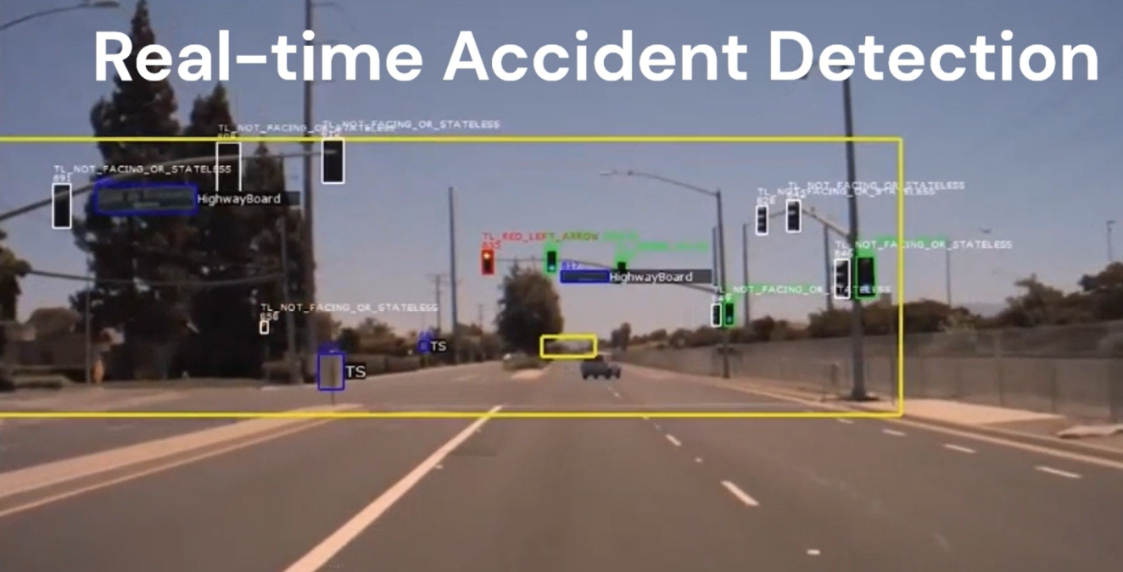

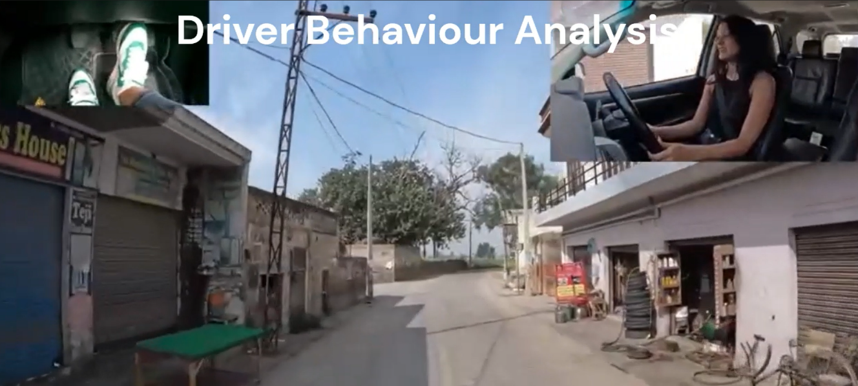

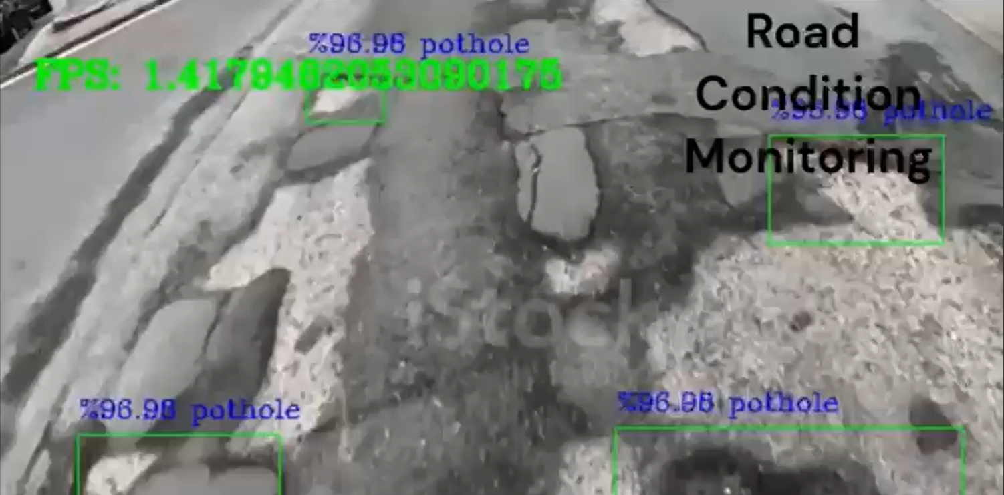

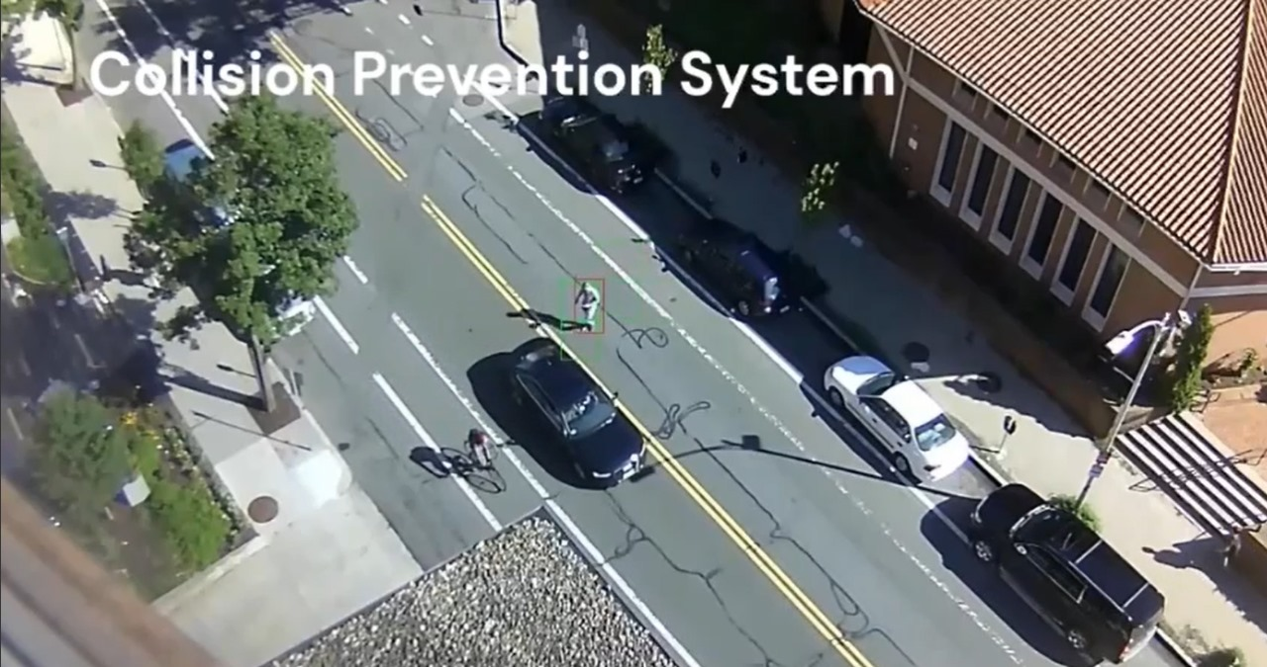

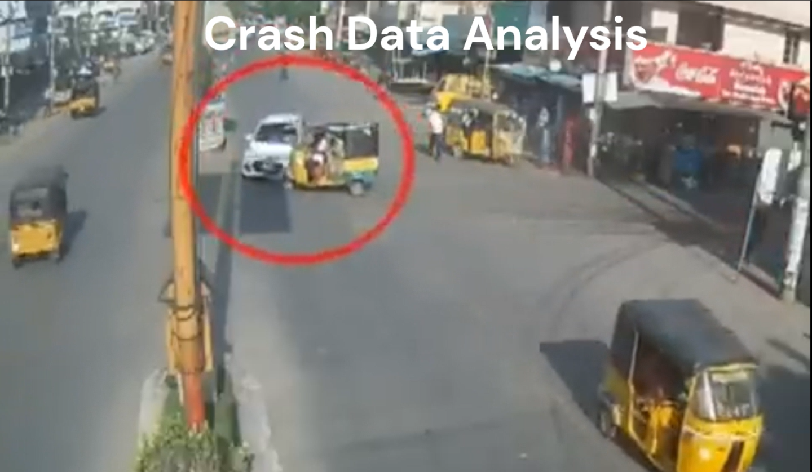

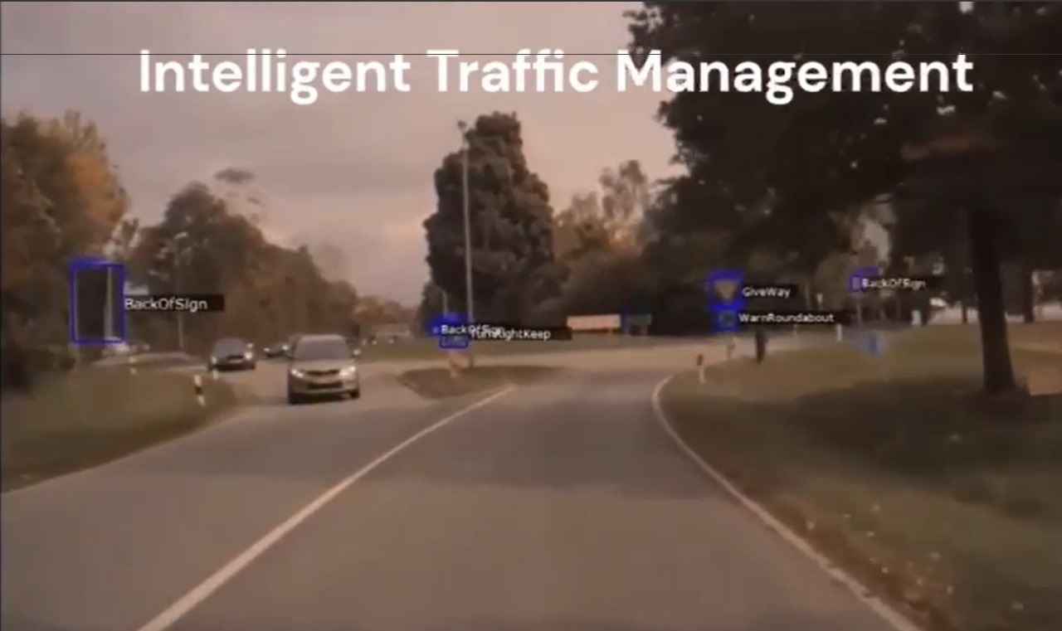

RESULTS:

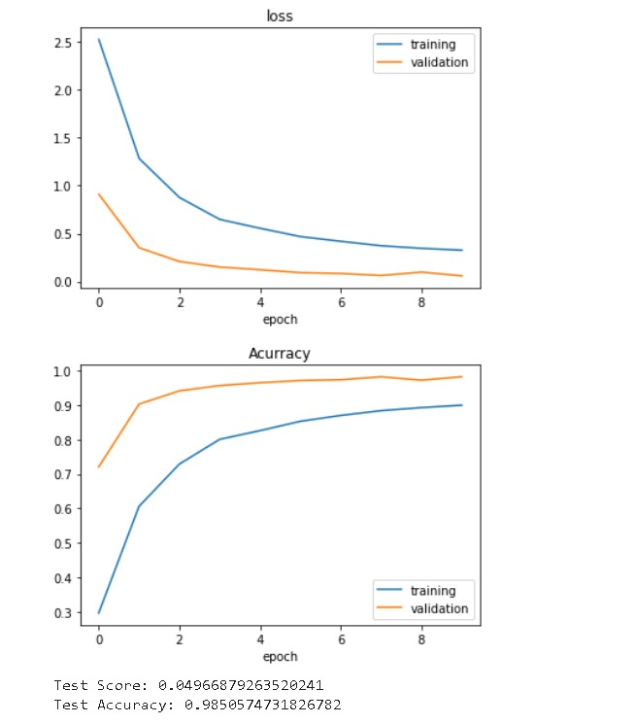

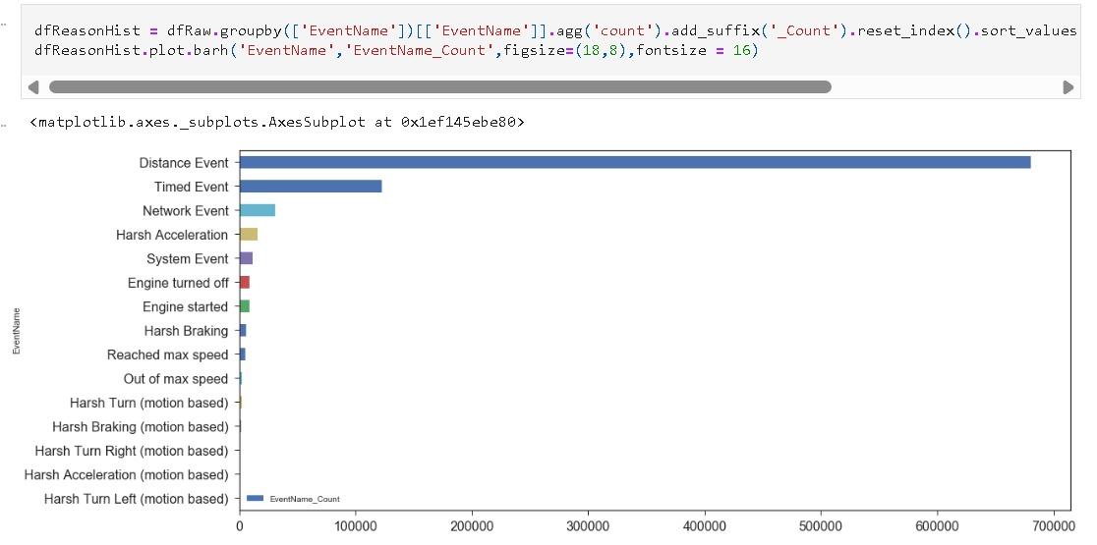

**CONCLUSION AND FUTURE ENHANCEMENTS**

Conclusion

In conclusion, the development of the road accident prevention system represents a significant step towards improving road safety and reducing the incidence of accidents. Through the integration of machine learning, deep learning, and computer vision techniques, the system can detect potential risks, analyzing driver behavior, recognizing traffic signs, detecting objects, and identifying potholes on the road. By providing real-time alerts and warnings to drivers and authorities, the system enables proactive measures to be taken to prevent accidents and minimize their impact.

Future Enhancement

While the current iteration of the road accident prevention system demonstrates promising capabilities, there are several areas for future enhancement and development:

* Enhanced Object Detection: Further improvement of object detection algorithms to accurately detect and classify a wider range of objects on the road, including rare or unusual objects.
* Advanced Driver Behavior Analysis: Development of more sophisticated models for driver behavior analysis, incorporating additional sensor data and contextual information to better understand driver intent and behavior.
* Integration with Autonomous Vehicles: Integration of the system with autonomous vehicle technologies to provide real-time feedback and guidance to autonomous vehicles, enhancing their safety and performance.
* Crowdsourced Data Collection: Implementation of crowdsourced data collection mechanisms to collect real-time data from drivers and vehicles on the road, enabling a more comprehensive and dynamic understanding of road conditions and hazards.

Predictive Analytics: Integration of predictive analytics techniques to forecast potential risks and hazards on the road based on historical data and trends, enabling proactive measures to be taken to prevent accidents before they occur.

Collaborative Partnerships: Collaboration with government agencies, transportation authorities, and other stakeholders to deploy the system on a wider scale and integrate it into existing infrastructure and road safety initiatives.

By addressing these areas for future enhancement, the road accident prevention system can further improve its effectiveness and contribute to the goal of creating safer and more secure roadways for all users.

In conclusion, the road accident prevention system showcases a significant advancement in improving road safety and reducing the incidence of accidents. Through the integration of machine learning, deep learning, and computer vision techniques, the system is capable of detecting potential risks, analyzing driver behavior, recognizing traffic signs, detecting objects, and identifying potholes on the road. With continued development and enhancement, the system has the potential to make great contributions to road safety and save lives.

**REFERENCES**

1. Road Accident Detection Using Machine Learning: IEEE Paper 2021 International Conference on System, Computation, Automation and Networking (ICSCAN)
2. https://www.ijert.org/automatic-vehicle-accident-detection-and-messageing-system
3. <https://www.ncbi.nlm.nih.gov/pmc/articles/PMC9146681/>
4. <https://www.researchgate.net/publication/369557935_Road_Car_Accident_Prediction_Using_a_Machine-Learning-Enabled_Data_Analysis>
5. <https://www.sciencedirect.com/science/article/pii/S2095756420301410>
6. <https://www.researchgate.net/publication/372293544_Real-Time_Vehicle_Accident_Recognition_from_Traffic_Video_Surveillance_using_YOLOV8_and_OpenCV>
7. <https://arxiv.org/abs/2208.06461>